Lab report 04


CSE 402L
Digital Signal Processing Fall 2024

Submitted by: Naveed Ahmad
Registration No.: 22PWCSE2165
Class Section: B
Semester :5th

“On my honor , as student of University of Engineering and Technology, I have neither given nor received unauthorized assistance on this academic work”

Student Signature: ____________

Submitted to:
Dr. Yasir Saleem Afridi

Nov. 18, 2024

Department of Computer Systems Engineering
University of Engineering and Technology Peshawar

Section 01:
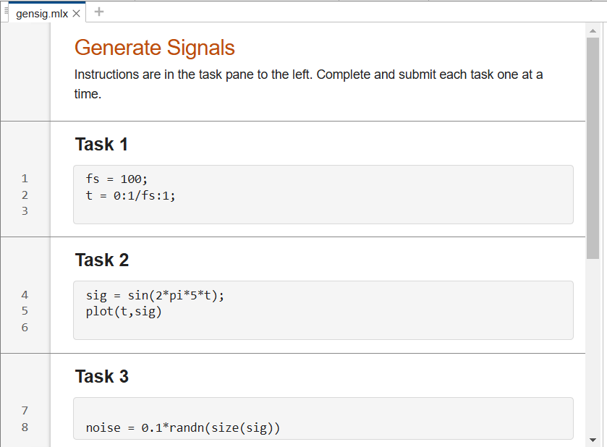
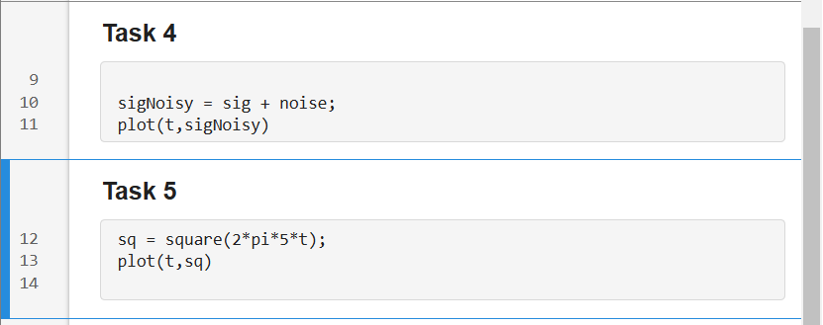
In this section I learnt how Defined the sampling frequency and created a time vector, Generated a 5 Hz sinusoidal signal using a mathematical formula, and Introduced random Gaussian noise to the generated sinusoidal signal.
Section 02:
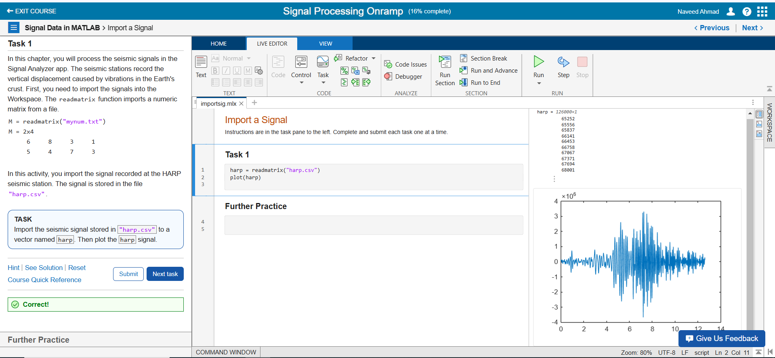
I learned how to import seismic data using readmatrix, store it in a variable, and plot the signal for analysis.

Section 03:
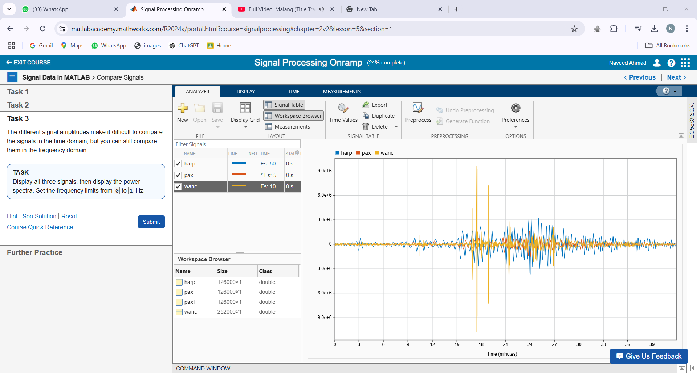In this section, I learned to display multiple signals, compare their amplitudes, and analyze them in the frequency domain.

Section 04:
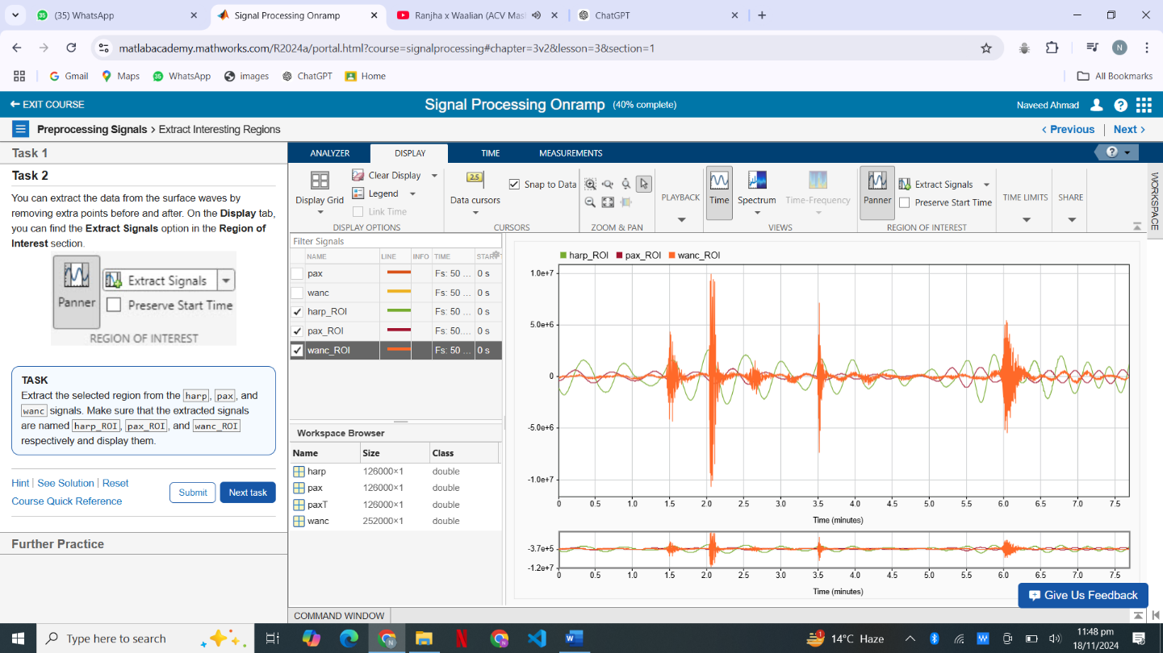
In this section I learnt how to extract signals from the region of interest, and functionality of panner tool in MATLAB.

